**3. Iteration (Unconditional loops)**

**Task 3:**

**Plan:**

1. Ask user to enter number of iterations for the Fibonacci sequence.
2. Accurately Validate if input is an integer, if not display error message and ask user to enter value again.
3. Define variables to store the sequence, and previous Values.
4. For loop Iterate number of times depending on input from user
5. Calculate the next value in sequence, and append to list.
6. Has for loop repeated number of times specified by user? If not repeat step 5.

**Pseudocode:**

valid 🡸 True

While valid = True:

Try:

Iterations 🡸 input as integer (“Enter number of iterations:”)

Valid 🡸 False

Except:

Output (error message)

Fibonacci 🡸 PreviousValues 🡸 [0,1]

For I in range (1, iterations):

PreviousValues 🡸 PreviousValues[1], sum(PreviousValues)

Fibonacci.append(PreviousValues)

Output ("Fibonacci sequence: ", *fibonacci)

**Variables table:**

|  |  |  |
| --- | --- | --- |
| Variable name | Data type | Comment |
| Valid | Boolean | Used in while loop to validate. stores Boolean value True. |
| Fibonacci | List | Stores Fibonacci sequence. |
| PreviousValues | List | Calculates and appends next value in sequence to variable fibonacci. |

**Screenshot evidence:**

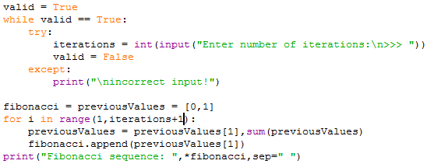

in the screenshot above, the user is asked to enter a number of iterations, there input must be an integer of it will be rejected by the try and except statements. If the input is rejected an error message will be displayed, and the user will be asked to enter a value again. Once the user’s input is accepted, the while loop will end. Variables “fibonacci” and “previousValues” are defined. A for loop then repeats for the number of iterations specified by the user. After every repeat the next value in the Fibonacci sequence is calculated using the last 2 values, and append to a list variable “fibonacci”. Finally, a print statement outputs the sequence.

**Sample run (Output):**

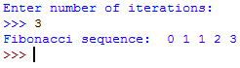Small number of iterations:

In this screenshot I have entered the number 3. The Fibonacci sequence has been displayed with the base numbers 0, 1 and the next 3 calculated values 1, 2, 3.

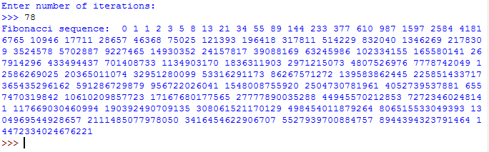Large number of iterations:

In this screenshot above, I have entered a larger number of 78. My code has displayed the Fibonacci sequence to 78 places.

Error message:

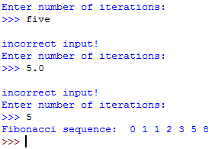in the screenshot to the left, I have entered “five”, the value has been rejected and an error message has been displayed. this shows that the validation of the user’s input is working correctly. Just to make sure, I then enter a float 5.0, and again an error message is displayed and I am asked to enter a value. Finally, I enter the integer 5 which is excepted and the sequence is displayed.

**Flowcharts:**

iterations 🡸 input as integer

START

For I in range (1, iterations+1). Is I = iterations?

fibonacci 🡸 previousValues = [0,1]

No

Output (error message)

Valid 🡸 False

Yes

Is iterations an integer?

Yes

No

While valid is equal to True. Is valid = True?

Valid 🡸 True

previousValues 🡸 previousValues[1],sum(previousValues)

END

Yes

Output ("Fibonacci sequence: ",fibonacci)

No

fibonacci.append(previousValues[1])